**Basic image processing- contrast enhancement**

**Objective**

To enhance nikko-si.tif image

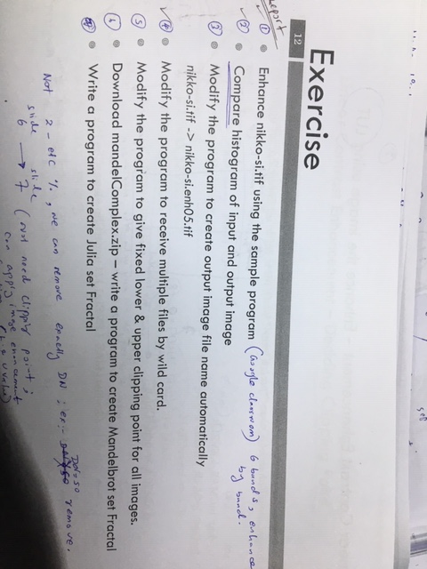

**Input image - nikko.tiff**

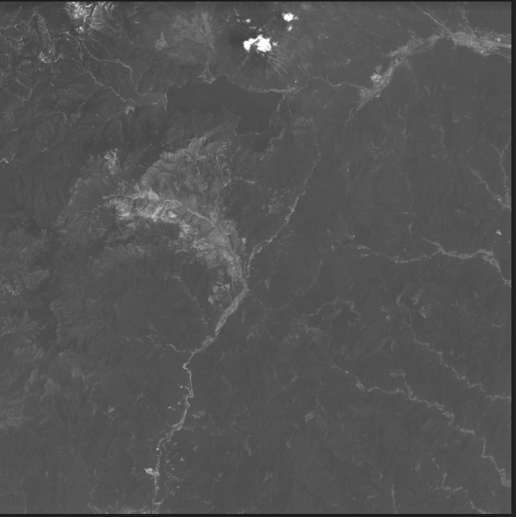

**Code description**

*//Define functions image.c and image.h for handling images on memory and some image functions which are in library which link by “image.h” and “imgio.h” for handling file I/O*/*

#include<stdio.h>

#include<math.h>

#include "image.h"

#include "imgio.h"

*/*define maximum DN value/\**

#define MAX_LEVEL 256

*/*Function statements*/*

int imageAccHist(u_char **pix, int w, int h, u_long *hist, u_long *accHist); */*Function to calculate accumulate histogram for each band*, **pix is pointing to pointer and addree of histogram and accumulated histogram/*

int clippingPoint(int clipPercent, u_long *accHist, int *lowerClip, int *upperClip); */*Function to calculate clipping point/\**

int imageLinearEnhance(u_char **pixI, u_char **pixO, int w, int h, int lowerClip, int upperClip); */*Function to enhance image/\**

void usage(void){

fprintf(stderr, "usage:contrast clipping_percent inputFile outputFile \n");

}

*/*Main function part*/*

int main(int argc, char *argv[]){

*/*three input parameters, clip percentage, input file name and output file name. percentage is integer and others are character data type */*

int clipPercent;

char *imgFNameI;

char *imgFNameO;

*/*declare working variables such as lower and upper clip, histogram maximum values, accumulated histogram max value, image and image files, image properties (h,w,n data and nchannel)*/*

*/*Declare variable for lowerClip and upperClip*/*

int lowerClip, upperClip;

*/*Declare variable for histogram and accumulate histogram using array type*/*

unsigned long hist[MAX_LEVEL], accHist[MAX_LEVEL];

IMAGE *imgI, *imgO;

IMAGE_FILE *imgFI, *imgFO;

int w, h, nchan, data_type;

*/*Declare agreement, not less than four agreements, if less or more than 4 exit program*/*

int ichan;

if (argc != 4){

usage();

exit(1);

}

*/*Set argument to integer which is clip percent- ARGUMENT 01, clip is a integer but argument is a character, in order to change atoi is used*/*

clipPercent = atoi(argv[1]);

*/*Set image file name of input from argument- ARGUMENT 02*/*

imgFNameI = argv[2];

*/* Set image file name of output- ARGUMENT 03/\**

imgFNameO = argv[3];

*/*checking clip percentage, if value is negative or more than 50% error, exit the program/\**

if (clipPercent < 0 || clipPercent>50){

usage();

fprintf(stderr, "contrast: clipping_percent must be 0-50:%d\n",clipPercent);

exit(2);

}

*/*Calling open input file function, obtain image’s w,h,nchan, and data type by read only and buffered. If file input is Null , exit the program*/*

imgFI = image_file_open(imgFNameI, IMAGE_RDONLY, IMAGE_BUFFERED);

if (imgFI == NULL){

fprintf(stderr, "contrast: input image file open error %s\n",imgFNameI);

exit(3);

}

if (imgFI->data_type != IMAGE_CHAR){ *\*/data type is character, 8bit image with pixel 256*/*

fprintf(stderr, "contrast: input image file must be 8 bit image %s\n",imgFNameI);

exit(3);

}

imgI = imgFI->image;

w = imgI->w;

h = imgI->h;

nchan = imgI->nchan;

data_type = imgI->data_type;

*/*Allocate memory for output image. Input and putput images are supposed to be the same. Data type are same. If there is error in output image paramer , error and exit the program*/*

imgO = image_alloc(w, h, data_type, nchan);

if (imgO == NULL){

fprintf(stderr, "contrast: output image file allocate error %d %d %d\n",w,h,nchan);

exit(4);

}

*/*Print out parameters which are information for output image*/*

printf("contrast: %s->%s%d%% w:%d h:%d nchan%d\n", imgFNameI, imgFNameO, clipPercent, w, h, nchan);

*/*Calling functions run band by band include accumulate histogram calculate*

*function, clipping point function, and image enhancement function*/*

for (ichan = 0; ichan < nchan; ichan++){

imageAccHist(imgI->data[ichan], w, h, hist, accHist);

clippingPoint(clipPercent, accHist, &lowerClip, &upperClip);

printf("chanl %d lower %d\n", ichan, lowerClip, upperClip);

imageLinearEnhance(imgI->data[ichan], imgO->data[ichan], w, h, lowerClip, upperClip);

}

*/*Create output image file*/*

imgFO = image_file_create(imgFNameO, IMAGE_TRUNC, 0, imgO);

if (imgFO == NULL){

fprintf(stderr, "contrast: output image file create error %s\n",imgFNameO);

exit(5);

}

*/*Close output image, destroy memory and close input image*/*

image_file_close(imgFO);

image_destroy(imgO);

image_file_close(imgFI);

return 0;

}

*/*Function to calculate accumulate histogram for each band, unsigned long hist{0}-{256}. */*

int imageAccHist(u_char **pix, int w, int h, u_long *hist, u_long *accHist){

int i, j, k;

for (k = 0; k < MAX_LEVEL; k++){ */*histogram calculation start from 0/\**

hist[k] = 0;

}

for (i = 0; i < h; i++) */*/then go ROW*columns by starting from i=0;j=0.\**

for (j = 0; j < w; j++)

hist[pix[i][j]]++;

accHist[0] = hist[0];

for (k = 1; k < MAX_LEVEL; k++)

accHist[k] = accHist[k - 1] + hist[k];

#if defined(VERBOSE)

for (k = 1; k < MAX_LEVEL; k++)

printf("%5d\t%9d\t%9d\n", k, hist[k], accHist[k]);

#endif

return 0;

}

*/*Function to calculate clipping point which is lower clipping point and upper*

*clipping point for image enhancement function*/*

int clippingPoint(int clipPercent, u_long *accHist, int *lowerClip, int *upperClip){

int k;

u_long nPix; */*how many pixel in total is nPix and it calculate/\**

nPix = accHist[MAX_LEVEL - 1]; */*accumulated max_level of hisogram = 255 = nPix= Total Pixel/\**

*lowerClip = 0;

for (k = 0; k < MAX_LEVEL; k++){

if ((double)accHist[k] / nPix * 100 >= clipPercent){

*lowerClip = k; */*when accumulated histo is less than lowerclip percentage ;break the program/\**

break;

}

}

*upperClip = MAX_LEVEL - 1;

for (k = *lowerClip; k < MAX_LEVEL; k++){

if ((double)accHist[k] / nPix * 100 >= 100-clipPercent){

*upperClip = k; */*when accumulated histo is upper than upper clip percentage ;break the program/\**

break;

}

}

return 0;

}

*/*Function to enhance image by cutting at lower clipping point and upper clipping*

*point and then straight the value to 0-255*/*

int imageLinearEnhance(u_char **pixI, u_char **pixO, int w, int h, int lowerClip, int upperClip){

int i, j, k;

u_char lut[MAX_LEVEL];

for (k = 0; k < MAX_LEVEL; k++){

if (k <= lowerClip){ *\*/until lut[k]=0*/*

lut[k] = 0;

}

else if (k >= upperClip){

lut[k] = MAX_LEVEL - 1; *\*/until lut[k]=Max*/*

}

else{

lut[k] = (double)(MAX_LEVEL - 1) / (upperClip - lowerClip)*(k - lowerClip);

}

}

for (i = 0; i < h; i++){ *\*/now check pixel by pixel , LUT values in each I and j*/*

for(j = 0; j < w; j++){

pixO[i][j] = lut[pixI[i][j]];

}

}

return 0;

}

**Output**

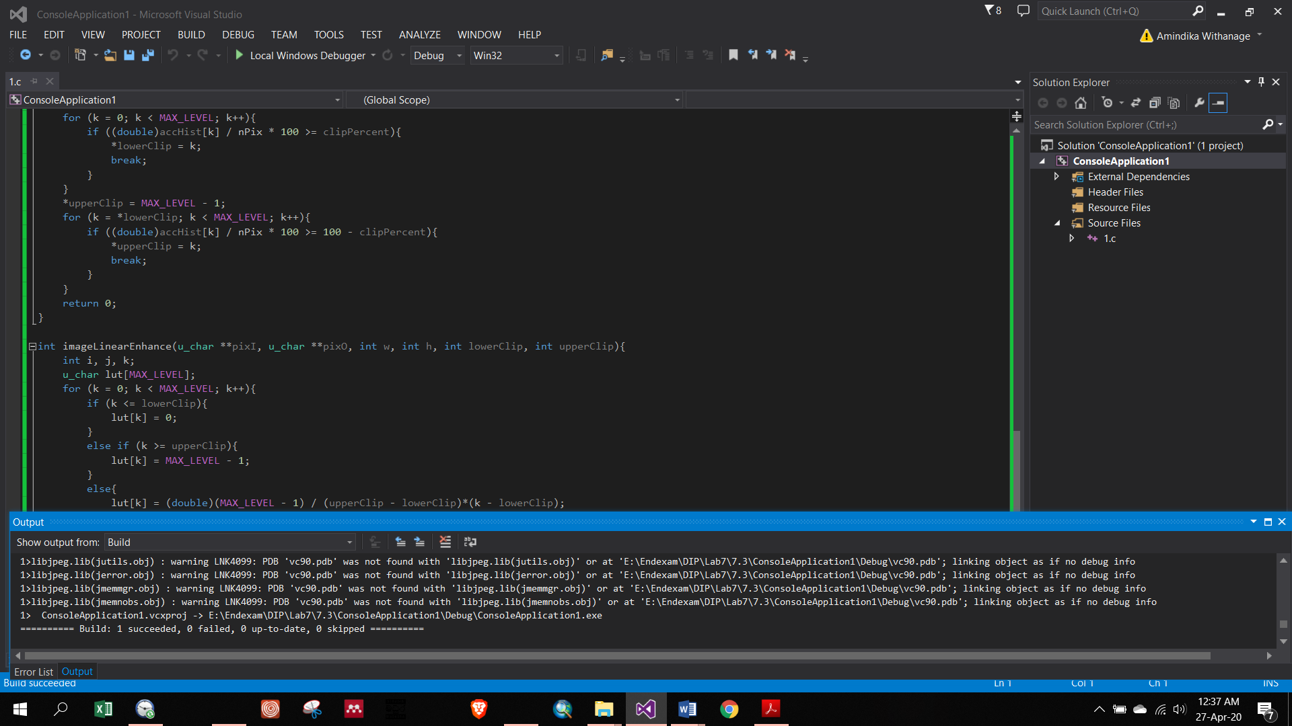

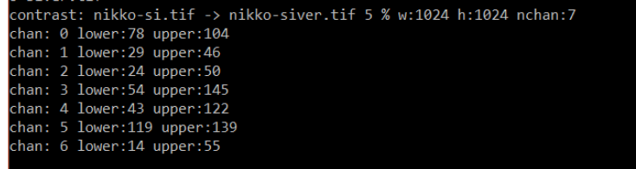

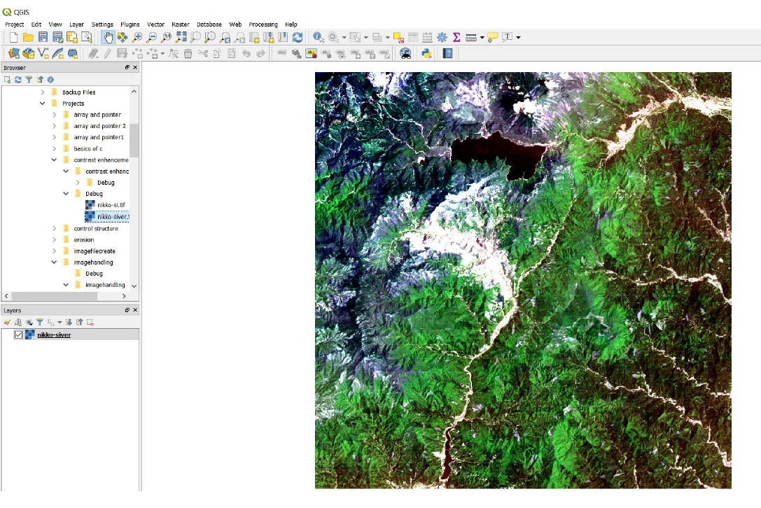

**Figure 1: Tiff output after changing histogram**